**WOULD YOU LIKE TO SPONSOR A GIRL’S SOFTBALL TEAM IN YOUR COMMUNITY AND GET EXPOSURE FOR YOUR BUSINESS?**

**INDEPENDENCE GIRLS SOFTBALL ASSOCIATION**

**SPONSOR'S CONTRACT**

It is hereby agreed that the undersigned will sponsor a team in the Independence Girls Softball Association at the level selected below, for one year. This form and the fee is due to I.G.S.A. by March 1, 2024. Equipment and uniforms will be provided by I.G.S.A. However, the sponsor hereby forfeits any right to control distribution of the stated fee with the understanding that all teams will be equipped equally. This contract extends through the softball season for the year 2024. The undersigned sponsor is relieved from any liability due to injury or personal damage.

Signed __________________________________________________________

Name of Company_________________________________________________

*\*Please e-mail your logo to IGSA@IGSASOFTBALL.COM*

Your representative we may contact:

Name: __________________________________________________________

Phone: __________________________________________________________

Address: ________________________________________________________

City: ____________________________ State: _________ Zip: ___________

Email or website: _______________________________________________________

Team, Coach or player you are associated with:________________________________

Please indicate which sponsorship level you would like (Team or League Sponsorship): _____________________________________________________________________

Would your business like a plaque to display at the end of the season? Yes No

Amount Enclosed: _______________________

Please make checks payable to **Independence Girls Softball Association** and

mail to:

IGSA Sponsorship % Melody Henthorne

2221 N Liberty St

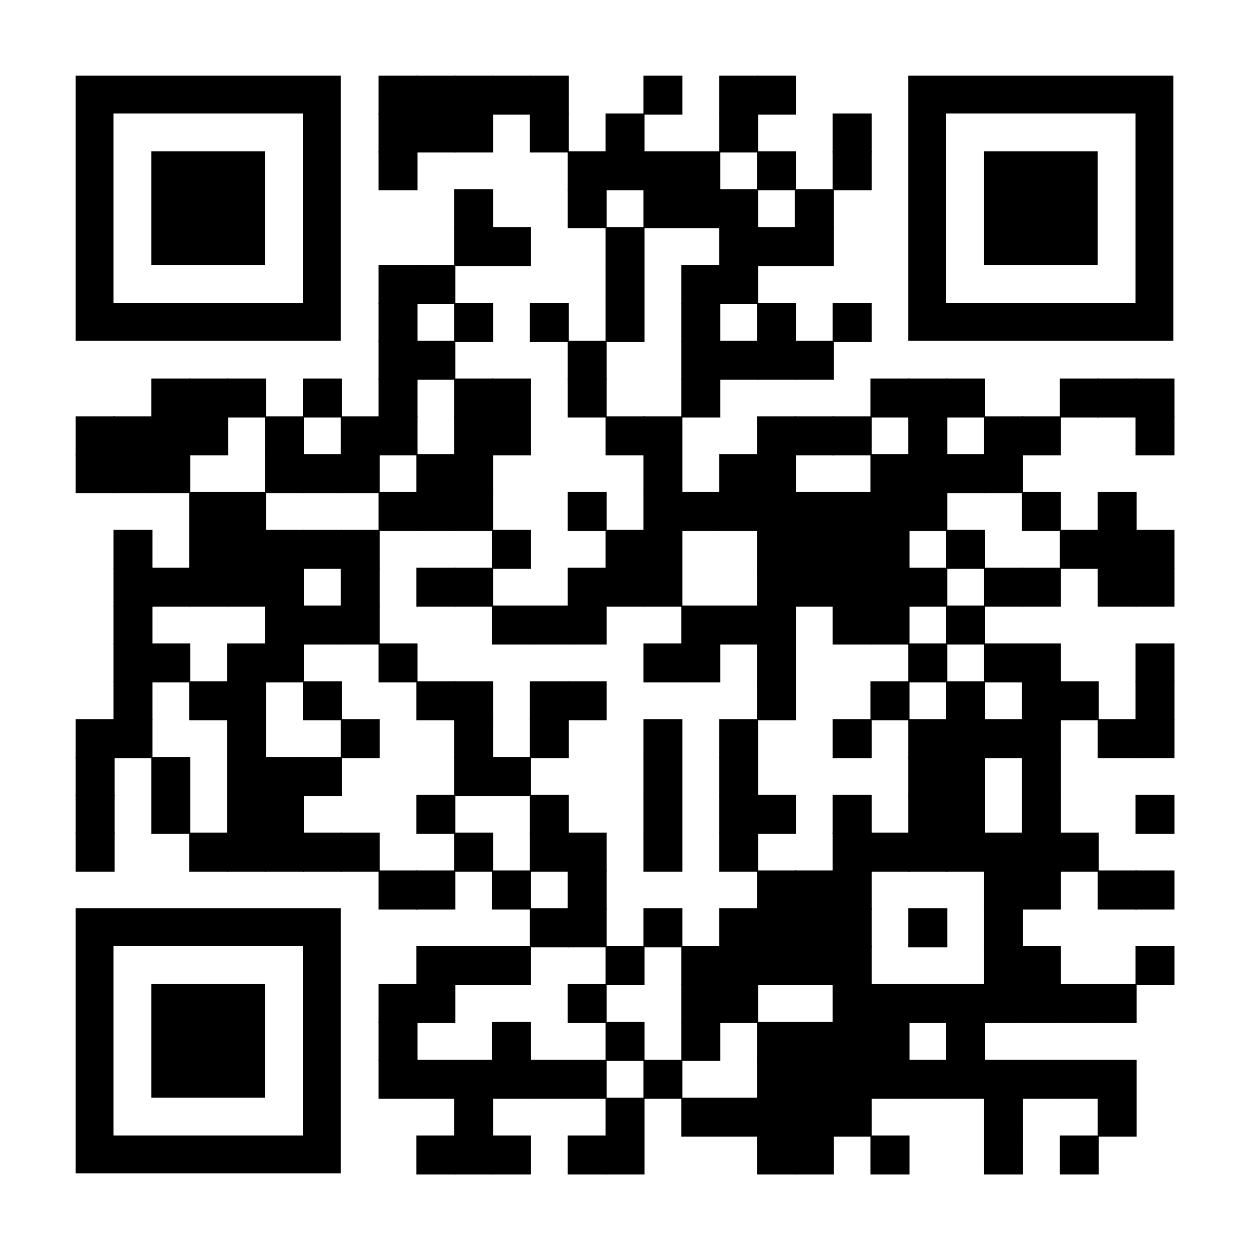Independence, MO 64050

Please call Melody with any questions: (816) 896-7377

[IGSA@IGSASOFTBALL.COM](mailto:IGSA@IGSASOFTBALL.COM)